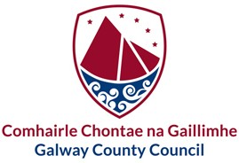

Oifigigh Phoiblí Ainmnithe i gComhairle Chontae na Gaillimhe

Designated Public Officials in Galway County Council

|  |  |
| --- | --- |
| **Executive Team** | |
| Liam Conneally | Príomhfheidhmeannach  Chief Executive |
| Katie O’Connor | Ceannasaí Airgeadais, Mótarchánach,TFC agus Claochlú Digiteach  Head of Finance, Motor Taxation, ICT and Digital Transformation |
| Eileen Ruane | Stiúrthóir Seirbhísí - Seirbhísí Corparáideacha, HR agus Leabharlanna Cathrach & Contae  Director of Services – Corporate Services, Environment and City & County Libraries |
| Liam Hanrahan | Stiúrthóir Seirbhísí - Pleanáil agus Forbairt Eacnamaíochta  Director of Services - Planning & Economic Development |
| Michael Owens | Stiúrthóir Seirbhísí - Tithíocht  Director of Services - Housing |
| Uinsinn Finn | Stiúrthóir Seirbhísí - Forbairt Fhisiciúil, Dóiteán & Seirbhisí Éigeandála agus Athrú Aeráide  Director of Services – Physical Development, Fire & Emergency Services and Climate Change |
| Jacqueline Carroll | Stiúrthóir Seirbhísí - Forbairt Tuaithe & Pobail agus  Comhcheangal & Timpeallacht  Director of Services – Rural & Community Development and Integration & Environment |